**I. Introduction**

After feasibility, studies and accounting for time and budget constraints, it seems a simple circuit modules will be designed to be tested, integrated and used to capture and convert a narrow band of the electromagnetic spectrum and convert to mechanical vibrations. This circuit will use some characteristic aspects of resistors, amplifiers, capacitors, inductors and a simple dipole antenna made from simple unfolded paper clips. A variable band pass filter will be used to narrow the band to specific frequencies. The selected and amplified signal is hoped to be converted into mechanical vibrations. This is done by using a transducer such as a speaker or earphone.

**II. DESIGN AND ASSEMBLY**

**Variable band pass module**

A variable band pass filter is accomplished by feeding the output of a low pass filter to a high pass filter. The low pass filter is made to be variable by introducing one component, a potentiometer with two of its three pins connected to serve as a variable resistor, and another component, a capacitor connected in parallel. This makes the band tunable. The output of this will be fed to a high pass filter. The result is the Eeshema shown below.

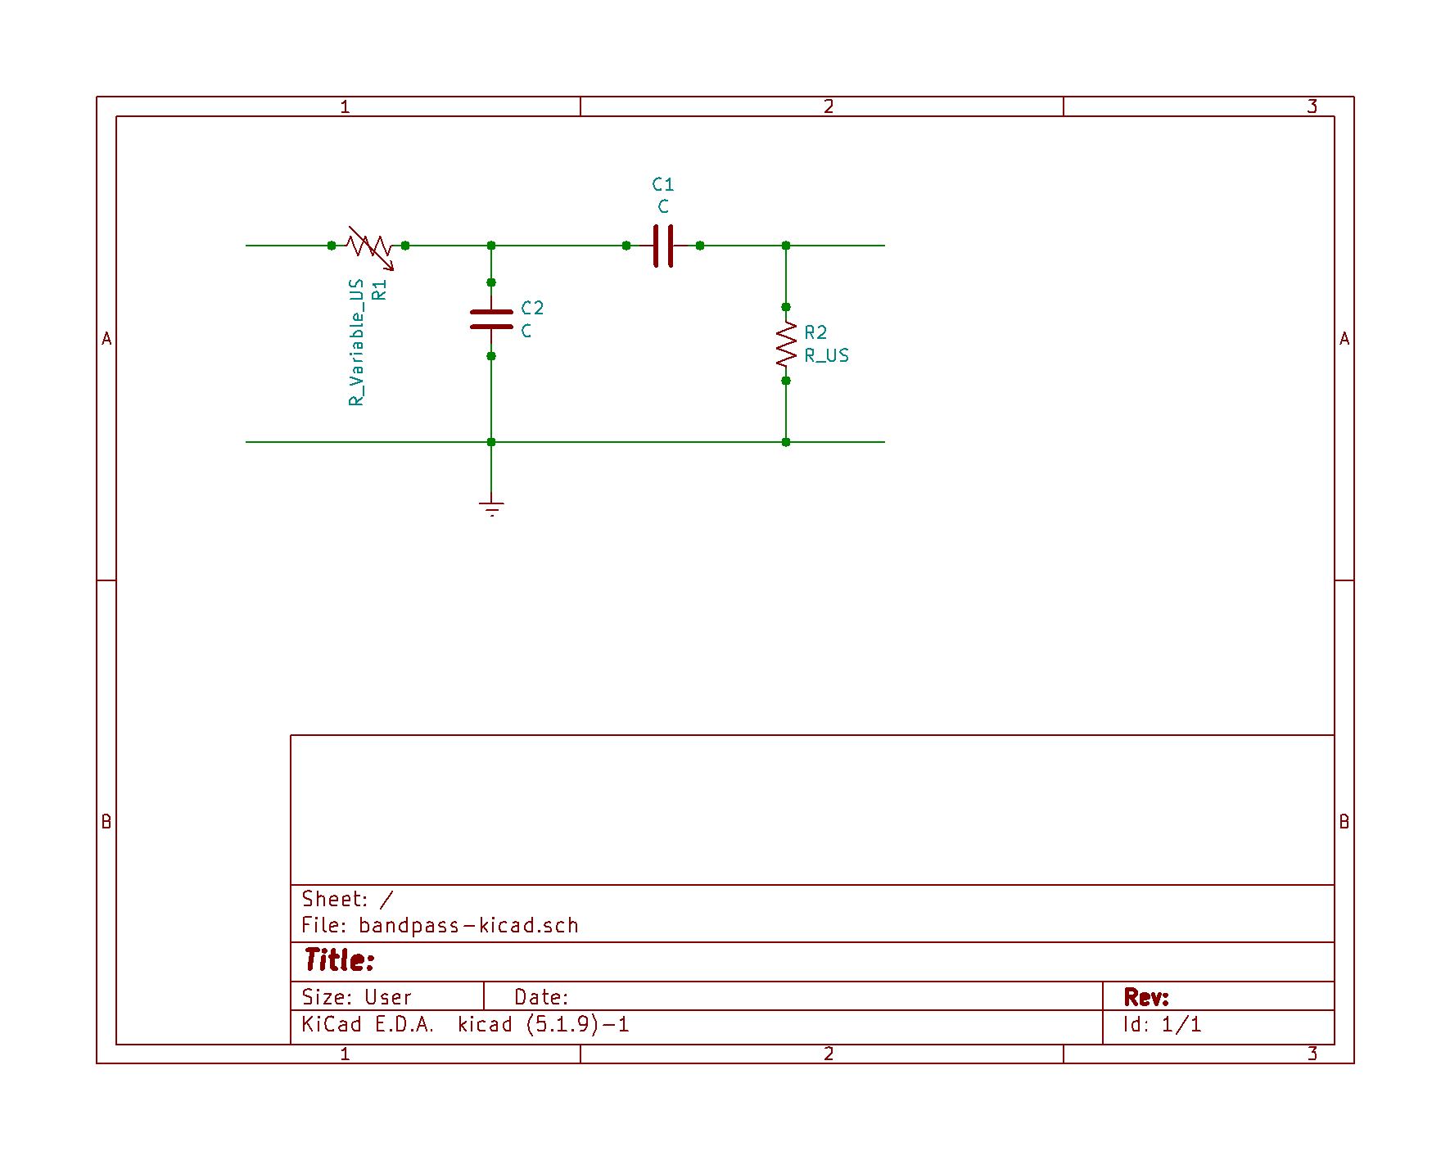

***Eeschema not exactly to scale of variable band pass filter module***

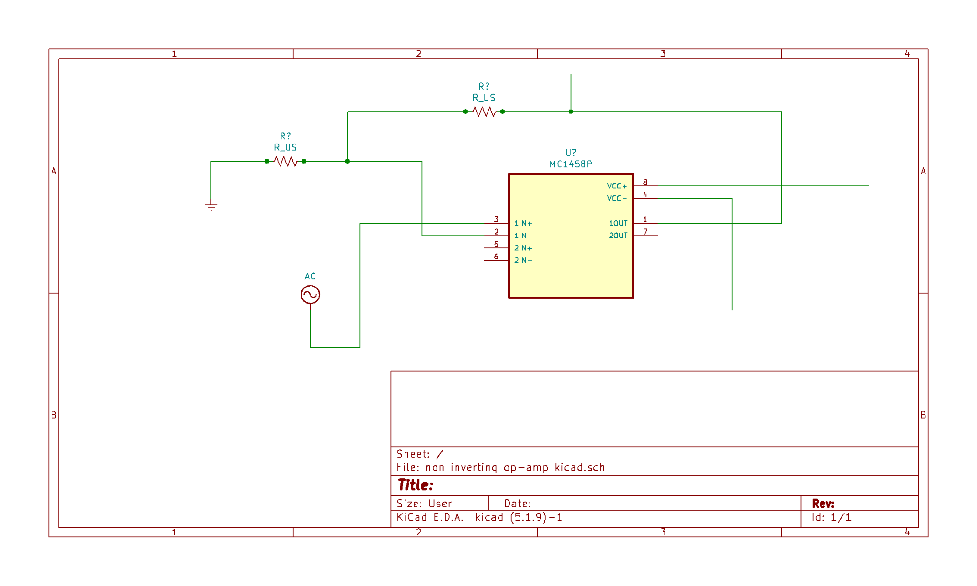

***Eeschema not exactly to scale of Op Amp module***

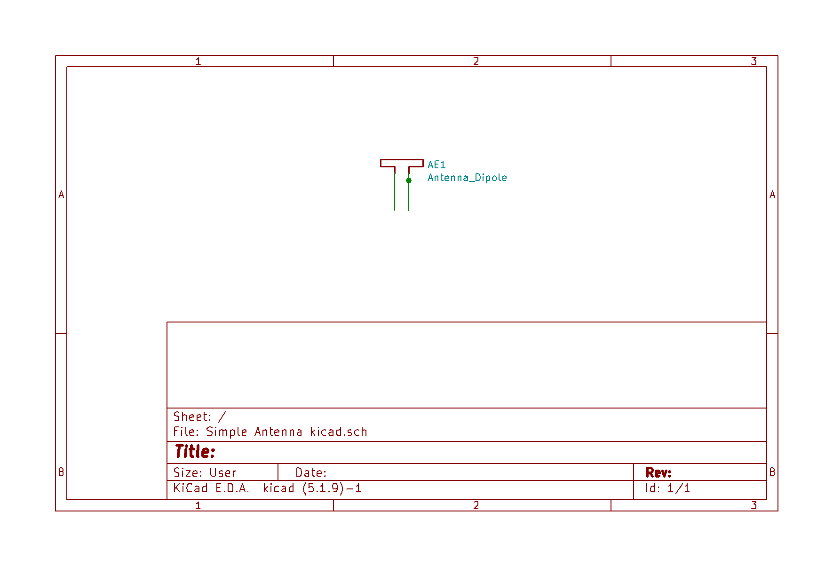***Eeschema not exactly to scale of a simple Antenna***

**Op Amp module**

An op Amp module is to be implemented to provide an amplification of +10. This is hoped to amplify a signal coming in from a dipole antenna. Eeshema shown as the 2nd image from the top.

**Dipole Antenna module**

This will be a module consisting of just one component. A dipole antenna made from a female to male connector used to attach to two unfolded paper clips. Eeshema shown as 3rd image from the top.

**III. OPERATION**

Tuning the knobs will change the RC characteristics of the circuit, and thus modify the operation band. The Q-factor and Gain will be noted at different operational settings.

**IV. TEST**

Tests will be performed using NI bode analyzer and other NI instruments tools. Final functional Demonstration The functioning characteristics of this circuit will be demonstrated live by means of numerical and graphical changes from modifying its characteristic parameters such as resistances and circuits.

**V. RESULTS**

With some luck it might be possible to isolate a signal, amplify it and measure gain. It might also be possible to convert this isolated signal into sound.

**VI. ACKNOWLEDGMENTS**

There are too many people to acknowledge. Class time and lab time have served me well